**DIFFERENTIATE BETWEEN HTTP1.1 VS HTTP2**

**HTTP 1.1:**

**HTTP/1.1, the first standardised version of HTTP, was introduced in 1997. It presented significant performance optimizations (over HTTP/0.9 and HTTP/1.0) and transformed the way requests and responses were exchanged between clients and servers.**

## **Key Features of HTTP/1.1:**

* It was no longer required for each connection to be terminated immediately after every request was served with a response; instead, with the keep-alive header, it was possible to have persistent connections. It allowed multiple requests/responses per TCP connection.
* The Upgrade header was used to indicate a preference from the client that made it possible to switch to a more preferred protocol if found appropriate by the server.
* HTTP/1.1 provided support for chunk transfers that allowed streaming of content dynamically as chunks and for additional headers to be sent after the message body. This enhancement was particularly useful in cases where values of a field remained unknown until the content had been produced. For example, when the content had to be digitally signed, it was not possible to do so before the entire content gets generated.
* Other features that reinforced its stability were introduced such as:
  + pipelining (the second request is sent before the response to the first is adequately served)
  + content negotiation (an exchange between client and server to determine the media type, it also provides the provision to serve different versions of a resource at the same URI)
  + cache control (used to specify caching policies in both requests and responses)

## The Protocol Designed to Speed Up Today’s Complex Web pages: HTTP/2

At the beginning of 2010, Google introduced an experimental protocol, SPDY, which supported multiplexing (multiple requests/responses sent and received asynchronously over a single TCP connection) but as it gained traction IETF’s HTTP Working Group came up with HTTP/2 in 2015, which is based on the SPDY protocol.

## 

## Key Features of HTTP/2:

* It introduces the concept of a server push where the server anticipates the resources that will be required by the client and pushes them prior to the client making requests. The client retains the authority to deny the server push; however, in most cases, this feature adds a lot of efficiency to the process.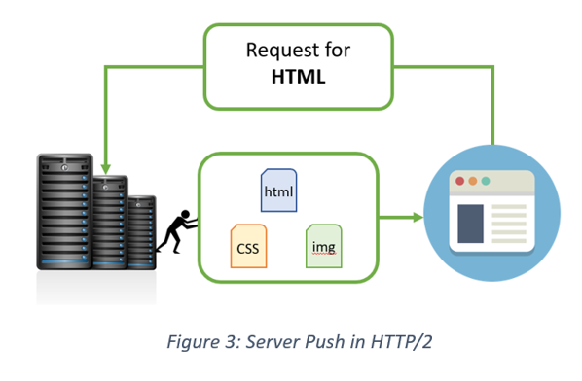

## **Introduces the concept of multiplexing that interleaves the requests and responses without head-of-line blocking and does so over a single TCP connection.**

## 

* **Introduces the concept of multiplexing that interleaves the requests and responses without head-of-line blocking and does so over a single TCP connection.**

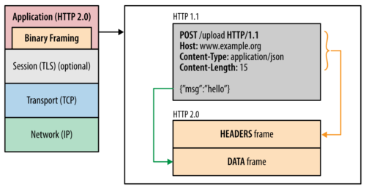

* **HTTP/2** uses the HPACK **header compression algorithm that is resilient to attacks like CRIME and** utilises **static Huffman encoding.**

**HTTP/3, the next version in the series, is based on Google’s QUIC which, unlike its precursors is a drastic shift to UDP. Given the gradual adoption rate of HTTP/2, HTTP/3 with its security challenges (that comes into play the moment we switch from TCP to UDP) is expected to face some difficulties.**

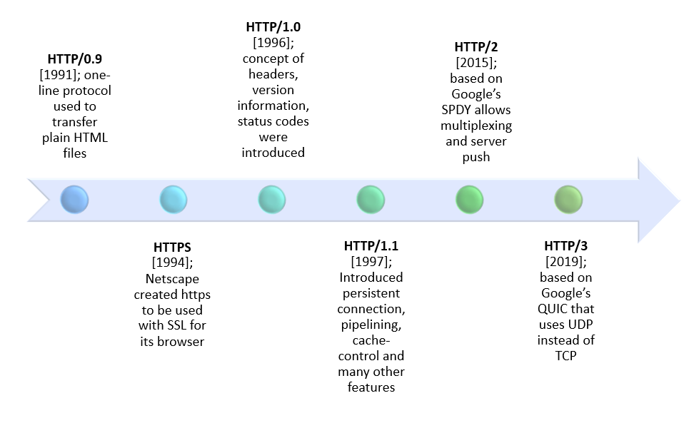

## HTTP/1.x vs HTTP/2: A Comparative Study

**HTTP2 Vs. HTTP1 is not a debate at all. HTTP2 is much faster and more reliable than HTTP1. HTTP1 loads a single request for every TCP connection, while HTTP2 avoids network delay by using multiplexing.**

**HTTP is a network delay sensitive protocol in the sense that if there is less network delay, then the page loads faster. However, an impressive increase in network bandwidth only slightly improves page load time. This is key to understanding the differences in performance efficiencies between the different versions of HTTP. Back in the day when people used dial up modems web pages were simple and it was the actual data transfer between the server and the client that contributed towards the largest chunk of the page load time. Today the actual downloading of resources from the server takes a negligible portion of the total page load time due to the tremendous increase in bandwidth availability. It is the time taken to establish the TCP connection and make requests that impacts performance. It was initially recommended to use only two connections per hostname but today most browsers use six connections per hostname. When we talk about http vs http2 in terms of performance it is important to note that a lot of performance optimizations adopted by HTTP/1.1 introduced complexities in terms of developmental efforts as well as network congestion that HTTP/2 attempts to address.**

**The table below points out the differentiating factors between http2 vs http1:**

Header CompressionHeaders are sent on every request leading to a lot of duplicate data being sent uncompressed across the wire.Header compression is included by default in HTTP/2 using HPACK.Performance OptimizationProvides support for caching to deliver pages faster.Sprinting, concatenating, inlining, domain sharding are some of the optimizations used as a workaround to the ‘six connections per host’ rule.Removes the need for unnecessary optimization hacks.Protocol TypeText based protocol that is in the readable form.It is a binary protocol (HTTP requests are sent in the form of 0s and 1s). Needs to be converted back from binary in order to read it.SecuritySSL is not required but recommended. Digest authentication used in HTTP 1.1 is an improvement over HTTP 1.0. HTTPS uses SSL/TLS for secure encrypted communication.Though security is still not mandatory, it is mostly encrypted (though it is not enforced) since almost all clients require traffic to be encrypted. It also has some minimum standards, such as minimum key size for encryption

| Differentiator | Http 1.1 | Http 2 |
| --- | --- | --- |
| Year | 1997 | 2015 |
| Key Features | It supports connection reuse i.e. for every TCP connection there could be multiple requests and responses, and pipelining where the client can request several resources from the server at once. However, pipelining was hard to implement due to issues such as head-of-line blocking and was not a feasible solution | Uses multiplexing, where over a single TCP connection resources to be delivered are interleaved and arrive at the client almost at the same time. It is done using streams which can be prioritized, can have dependencies and individual flow control. It also provides a feature called server push that allows the server to send data that the client will need but has not yet requested. |

| Status Code | Introduces a warning header field to carry additional information about the status of a message. Can define 24 status codes, error reporting is quicker and more efficient. | Underlying semantics of HTTP such as headers, status codes remains the same |
| --- | --- | --- |
| Authentication Mechanism | It is relatively secure since it uses digest authentication, NTLM authentication. | Security concerns from previous versions will continue to be seen in HTTP/2. However, it is better equipped to deal with them due to new TLS features like connection error of type Inadequate_Security. |
| Caching | Expands on the caching support by using additional headers like cache-control, conditional headers like If-Match and by using entity tags. | HTTP/2 does not change much in terms of caching. With the server push feature if the client finds the resources are already present in the cache, it can cancel the pushed stream. |
| Web Traffic | HTTP/1.1 provides faster delivery of web pages and reduces web traffic as compared to HTTP/1.0. However, TCP starts slowly and with domain sharding (resources can be downloaded simultaneously by using multiple domains), connection reuse and pipelining, there is an increased risk of network congestion. | HTTP/2 utilizes multiplexing and server push to effectively reduce the page load time by a greater margin along with being less sensitive to network delay |